# [OLD] Risultati ❌

All: ['market-price', 'total-bitcoins', 'market-cap', 'trade-volume', 'blocks-size', 'avg-block-size', 'n-transactions-total', 'n-transactions-per-block', 'hash-rate', 'difficulty', 'miners-revenue', 'transaction-fees-usd', 'n-unique-addresses', 'n-transactions', 'estimated-transaction-volume-usd', 'rate-of-change', 'sma-5-days', 'sma-7-days', 'sma-10-days', 'sma-20-days', 'sma-50-days', 'sma-100-days']

Corr: ['market-price', 'market-cap', 'miners-revenue', 'sma-5-days', 'sma-7-days', 'estimated-transaction-volume-usd', 'sma-10-days', 'n-transactions-total', 'blocks-size', 'sma-100-days', 'total-bitcoins', 'sma-50-days', 'sma-20-days', 'difficulty', 'hash-rate', 'n-unique-addresses']

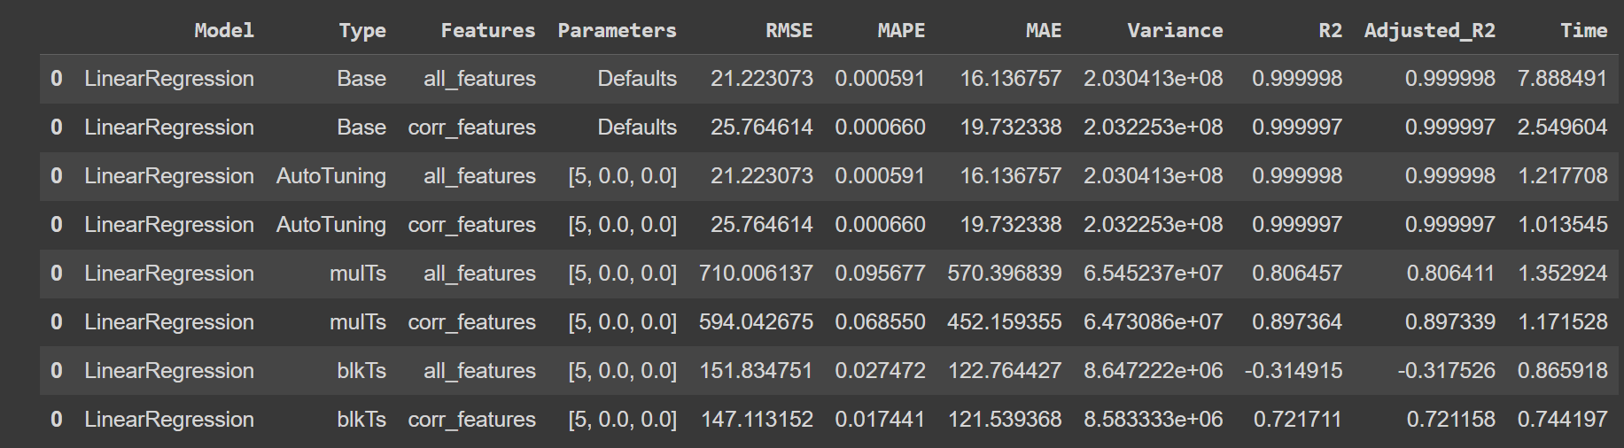

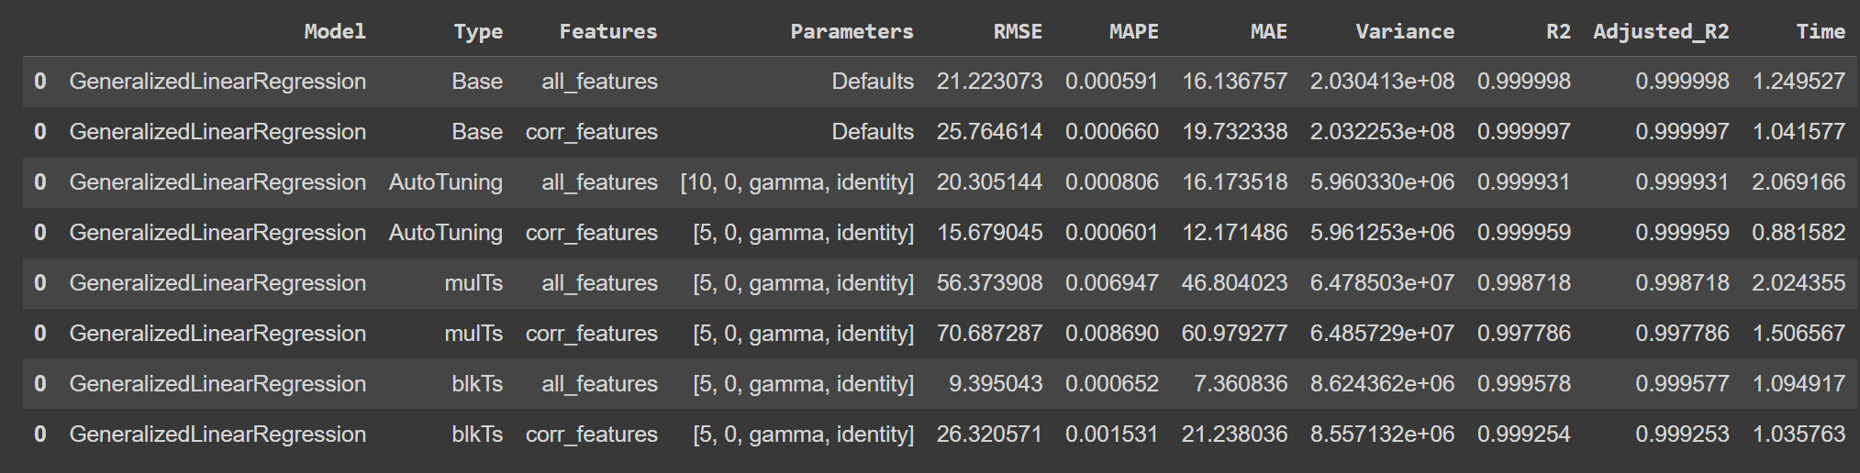

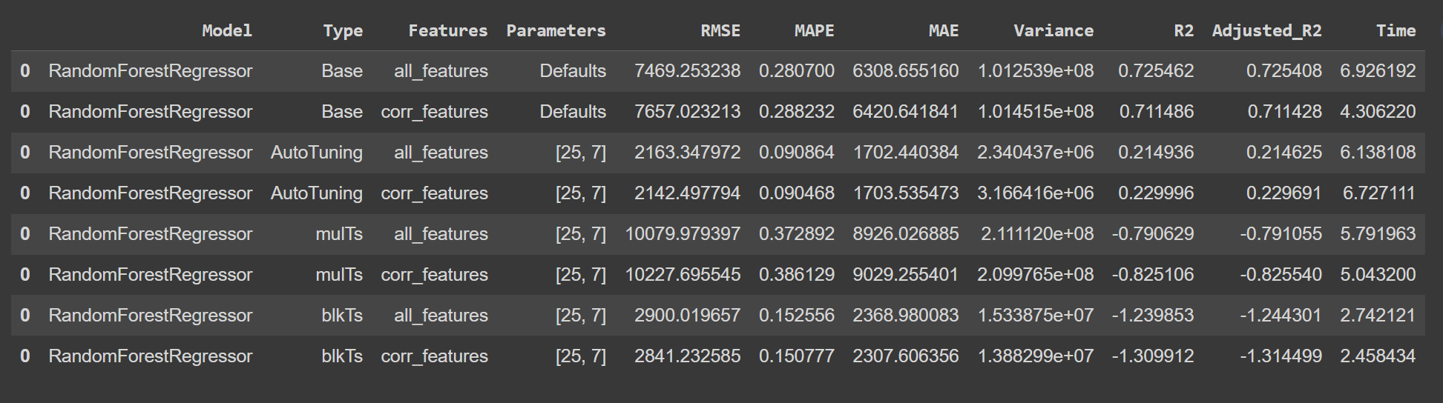







------------------------------------------------------------------------------------------------------------------------------------------

All: ['total-bitcoins', 'market-cap', 'trade-volume', 'blocks-size', 'avg-block-size', 'n-transactions-total', 'n-transactions-per-block', 'hash-rate', 'difficulty', 'miners-revenue', 'transaction-fees-usd', 'n-unique-addresses', 'n-transactions', 'estimated-transaction-volume-usd', 'rate-of-change', 'sma-5-days', 'sma-7-days', 'sma-10-days', 'sma-20-days', 'sma-50-days', 'sma-100-days']  
Corr: ['market-cap', 'miners-revenue', 'sma-5-days', 'sma-7-days', 'estimated-transaction-volume-usd', 'sma-10-days', 'n-transactions-total', 'blocks-size', 'sma-100-days', 'total-bitcoins', 'sma-50-days', 'sma-20-days', 'difficulty', 'hash-rate', 'n-unique-addresses']

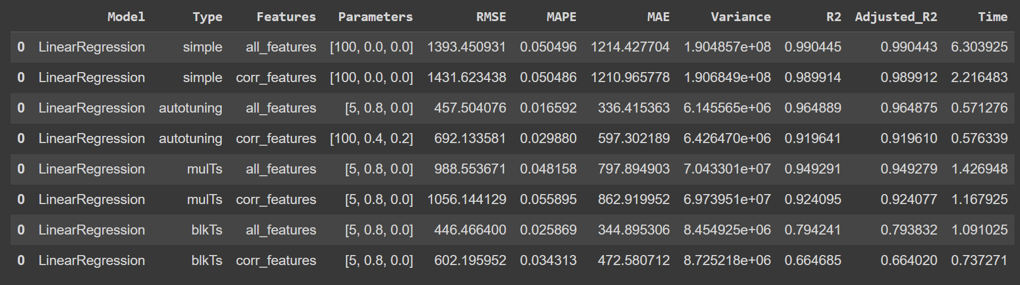

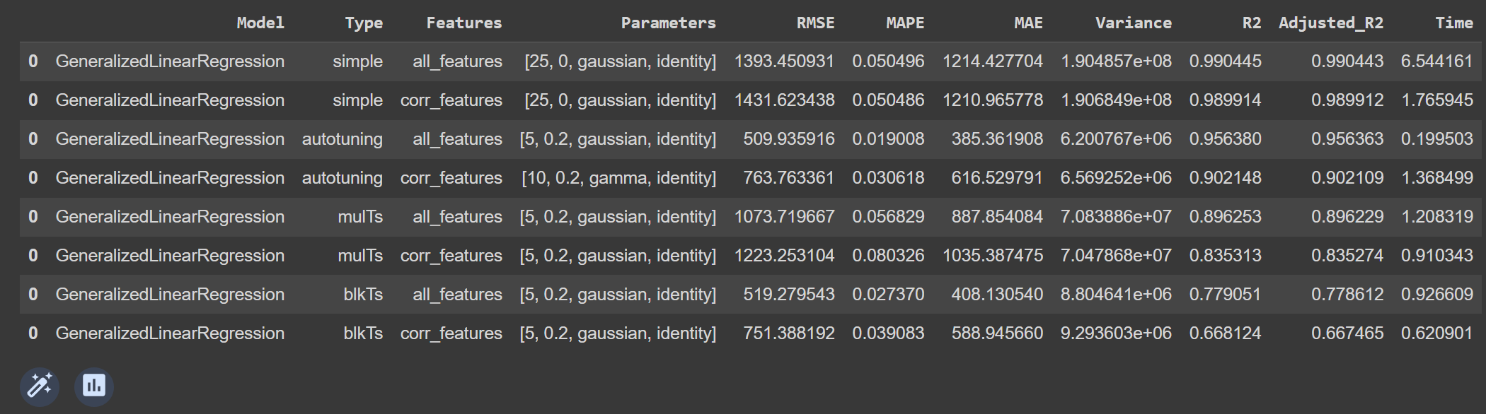

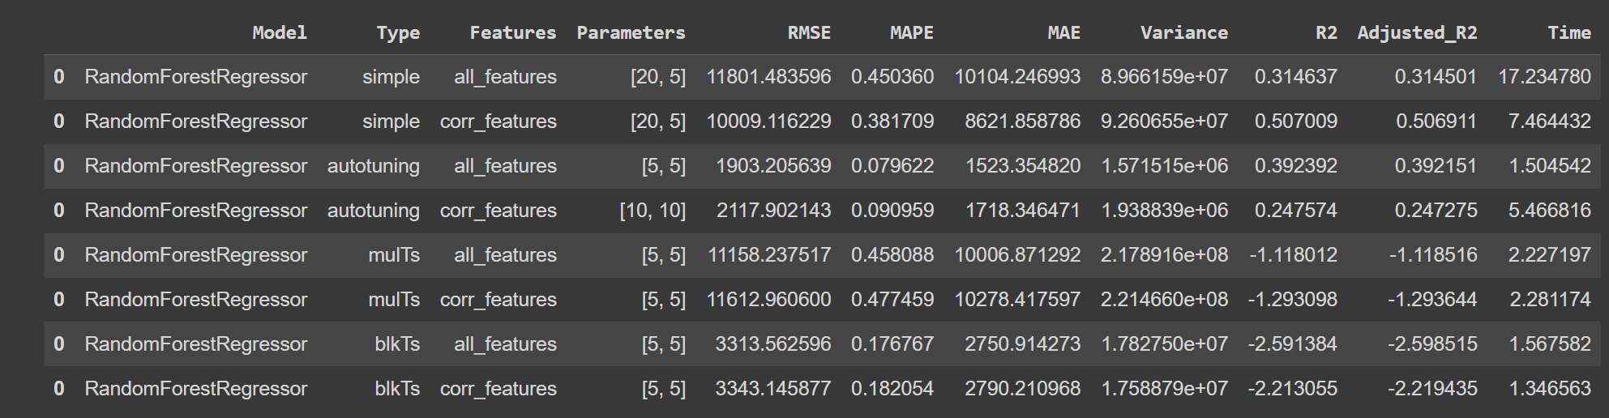

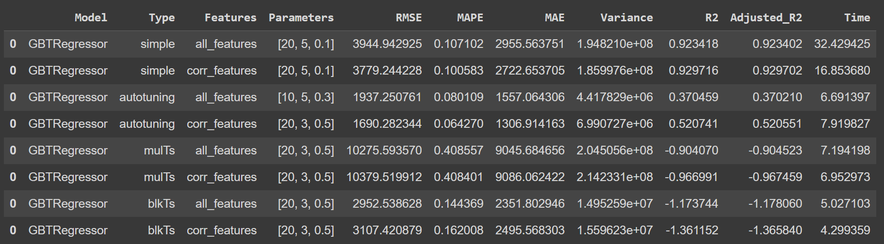

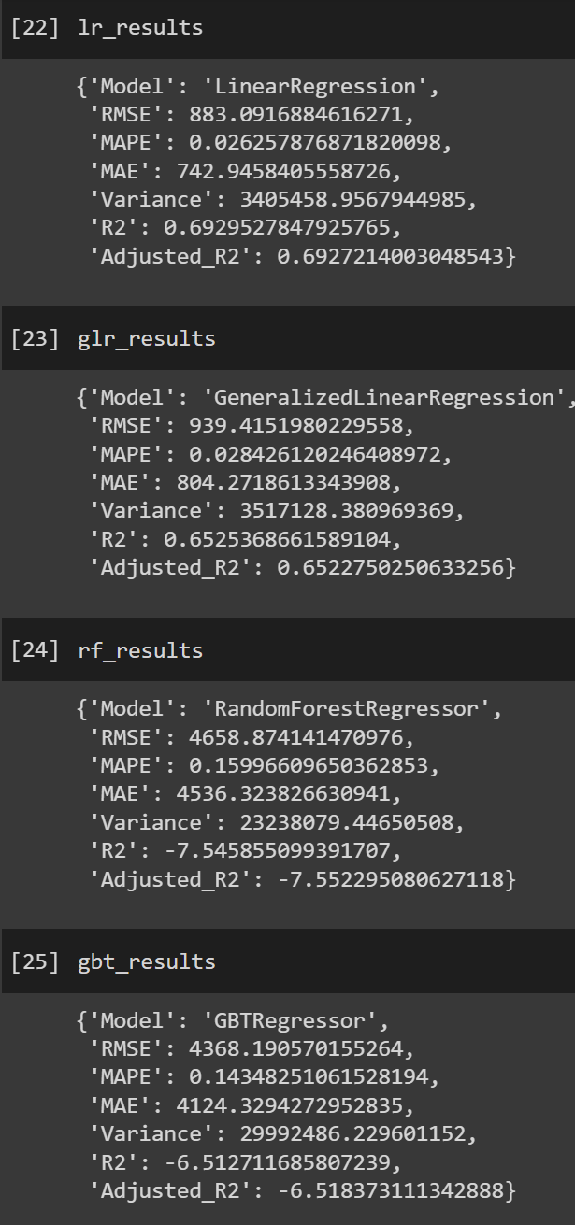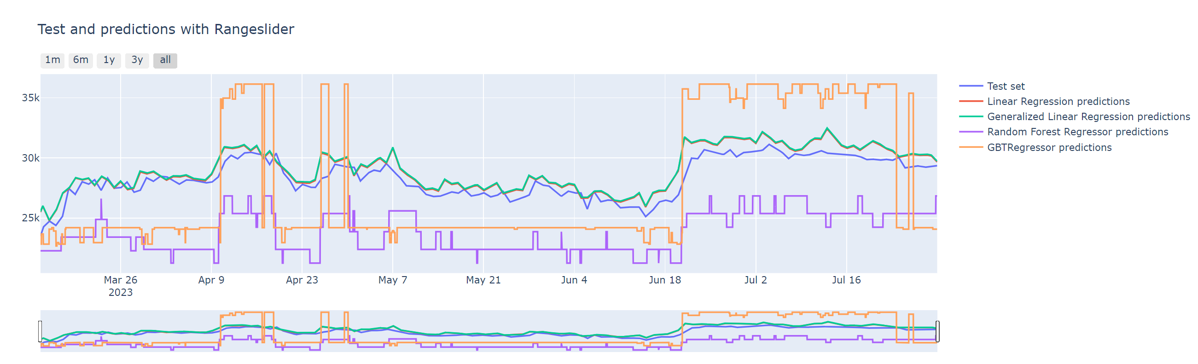

------------------------------------------------------------------------------------------------------------------------------------------

All: ["total-bitcoins", "market-cap", "trade-volume", "blocks-size", "avg-block-size", "n-transactions-total", "n-transactions-per-block", "hash-rate", "difficulty", "miners-revenue", "transaction-fees-usd", "n-unique-addresses", "n-transactions", "estimated-transaction-volume-usd", "rate-of-change", "sma-5-days", "sma-7-days", "sma-10-days", "sma-20-days", "sma-50-days", "sma-100-days"]

More rel (corr > 7): ["market-cap", "miners-revenue", "sma-5-days", "sma-7-days", "estimated-transaction-volume-usd", "sma-10-days", "n-transactions-total", "blocks-size", "sma-100-days", "total-bitcoins"]

Less rel (corr <= 7): ["sma-20-days", "sma-50-days", "n-unique-addresses", "difficulty", "hash-rate", "avg-block-size", "transaction-fees-usd", "trade-volume", "n-transactions-per-block", "n-transactions", "rate-of-change"]

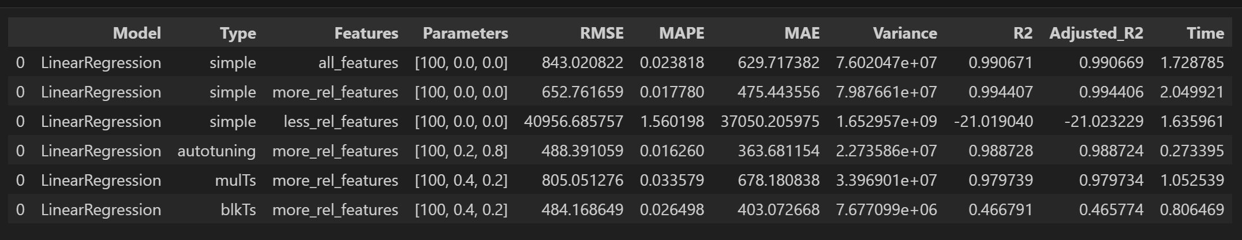

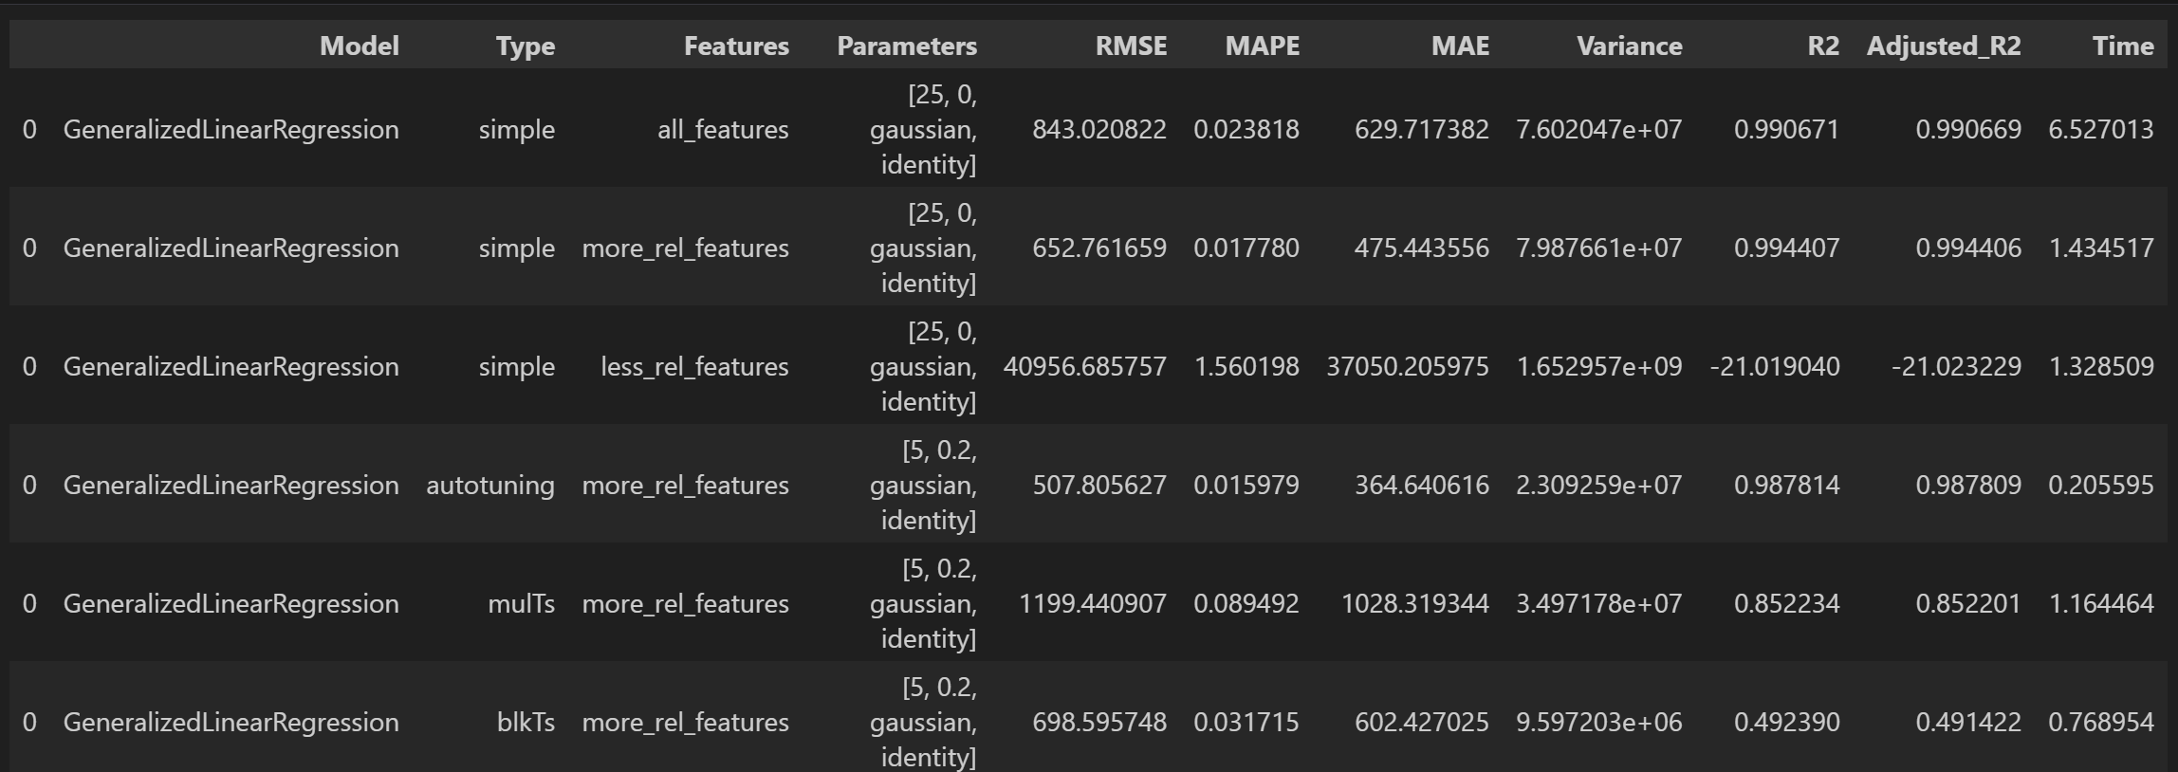

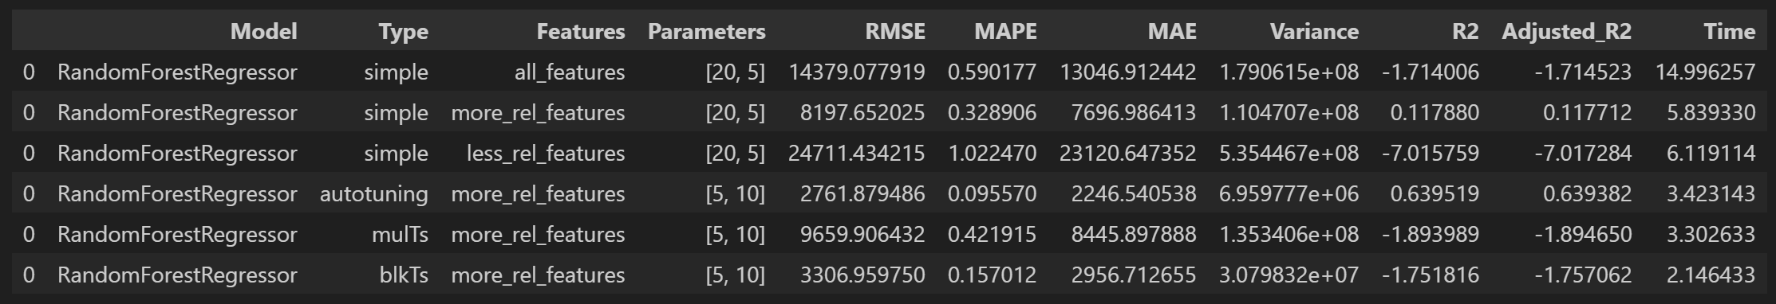

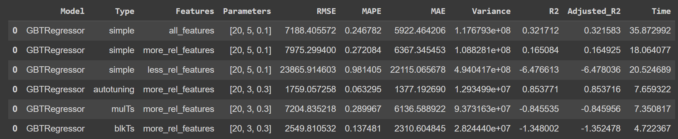

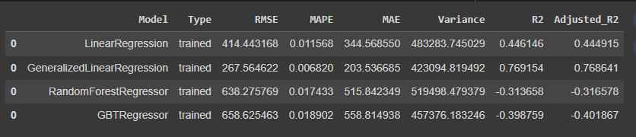

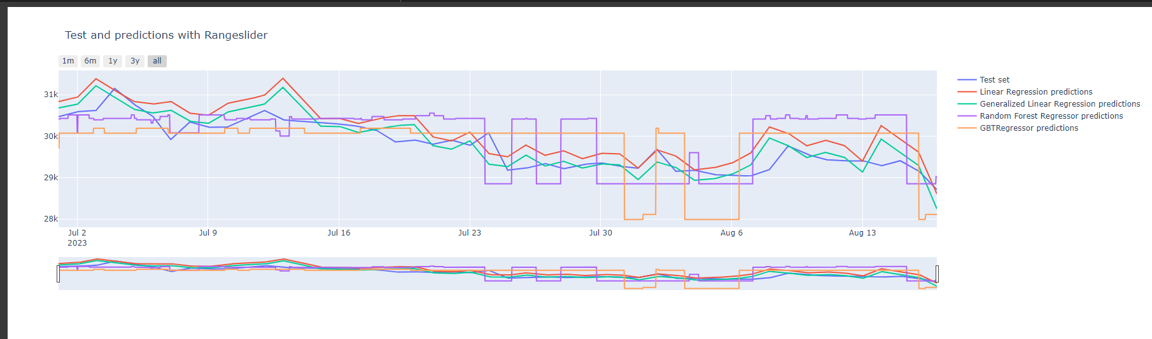

------------------------------------------------------------------------------------------------------------------------------------------

Con normalizzazione  
All: ["total-bitcoins", "market-cap", "trade-volume", "blocks-size", "avg-block-size", "n-transactions-total", "n-transactions-per-block", "hash-rate", "difficulty", "miners-revenue", "transaction-fees-usd", "n-unique-addresses", "n-transactions", "estimated-transaction-volume-usd", "rate-of-change", "sma-5-days", "sma-7-days", "sma-10-days", "sma-20-days", "sma-50-days", "sma-100-days"]

More rel (corr > 7): ["market-cap", "miners-revenue", "sma-5-days", "sma-7-days", "estimated-transaction-volume-usd", "sma-10-days", "n-transactions-total", "blocks-size", "sma-100-days", "total-bitcoins"]

Less rel (corr <= 7): ["sma-20-days", "sma-50-days", "n-unique-addresses", "difficulty", "hash-rate", "avg-block-size", "transaction-fees-usd", "trade-volume", "n-transactions-per-block", "n-transactions", "rate-of-change"]

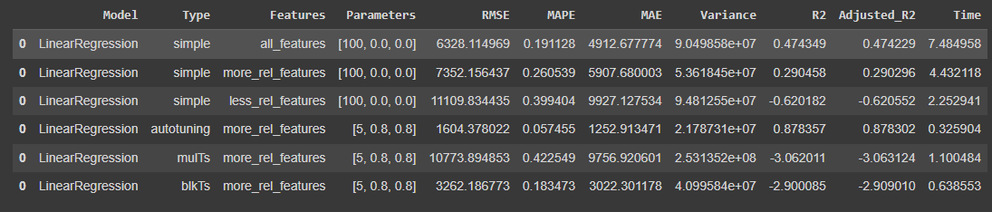

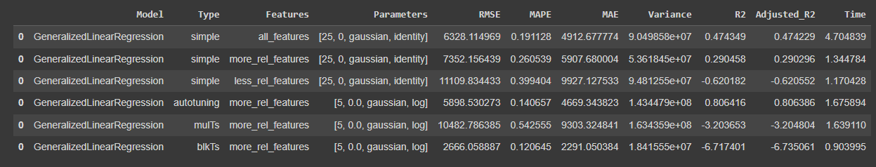

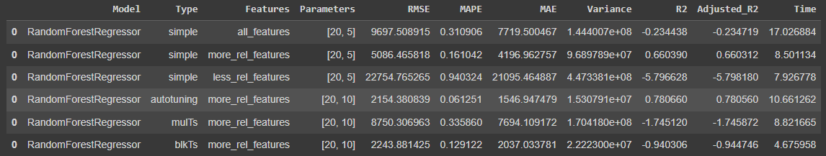

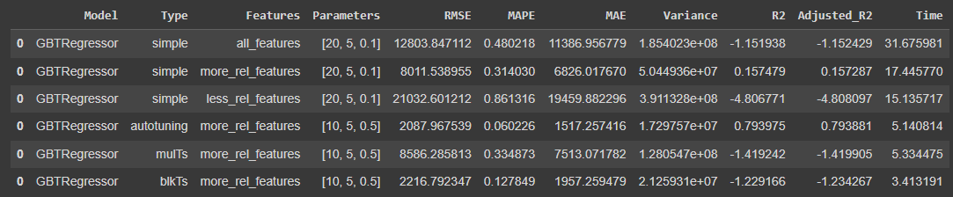

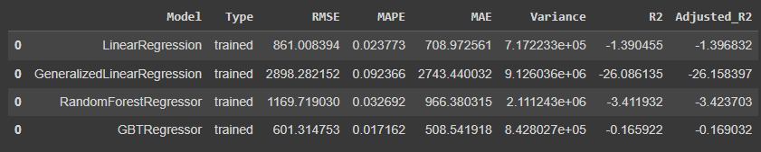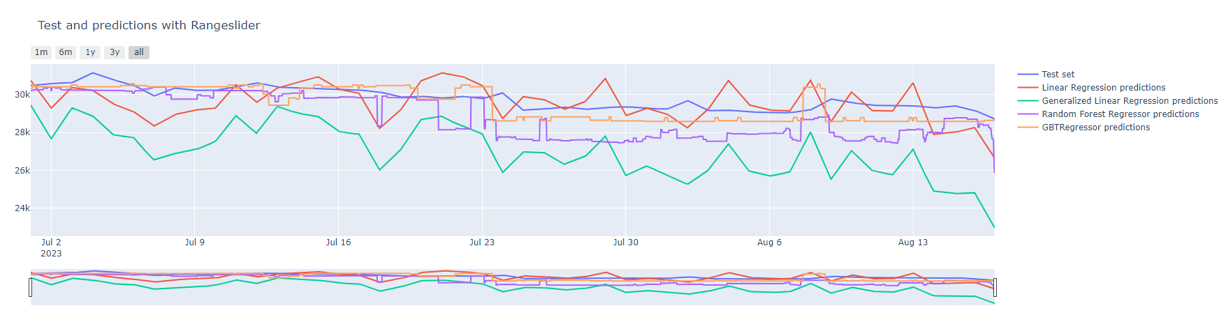

------------------------------------------------------------------------------------------------------------------------------------------

Con standardizzazione  
All: ["total-bitcoins", "market-cap", "trade-volume", "blocks-size", "avg-block-size", "n-transactions-total", "n-transactions-per-block", "hash-rate", "difficulty", "miners-revenue", "transaction-fees-usd", "n-unique-addresses", "n-transactions", "estimated-transaction-volume-usd", "rate-of-change", "sma-5-days", "sma-7-days", "sma-10-days", "sma-20-days", "sma-50-days", "sma-100-days"]

More rel (corr > 7): ["market-cap", "miners-revenue", "sma-5-days", "sma-7-days", "estimated-transaction-volume-usd", "sma-10-days", "n-transactions-total", "blocks-size", "sma-100-days", "total-bitcoins"]

Less rel (corr <= 7): ["sma-20-days", "sma-50-days", "n-unique-addresses", "difficulty", "hash-rate", "avg-block-size", "transaction-fees-usd", "trade-volume", "n-transactions-per-block", "n-transactions", "rate-of-change"]

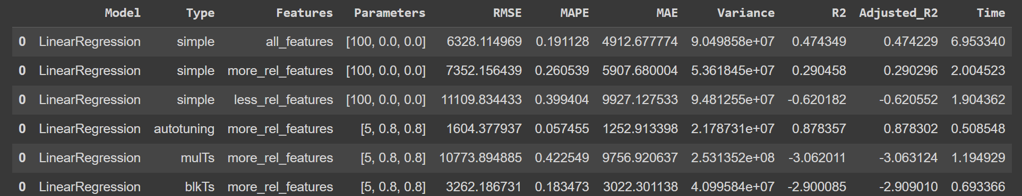

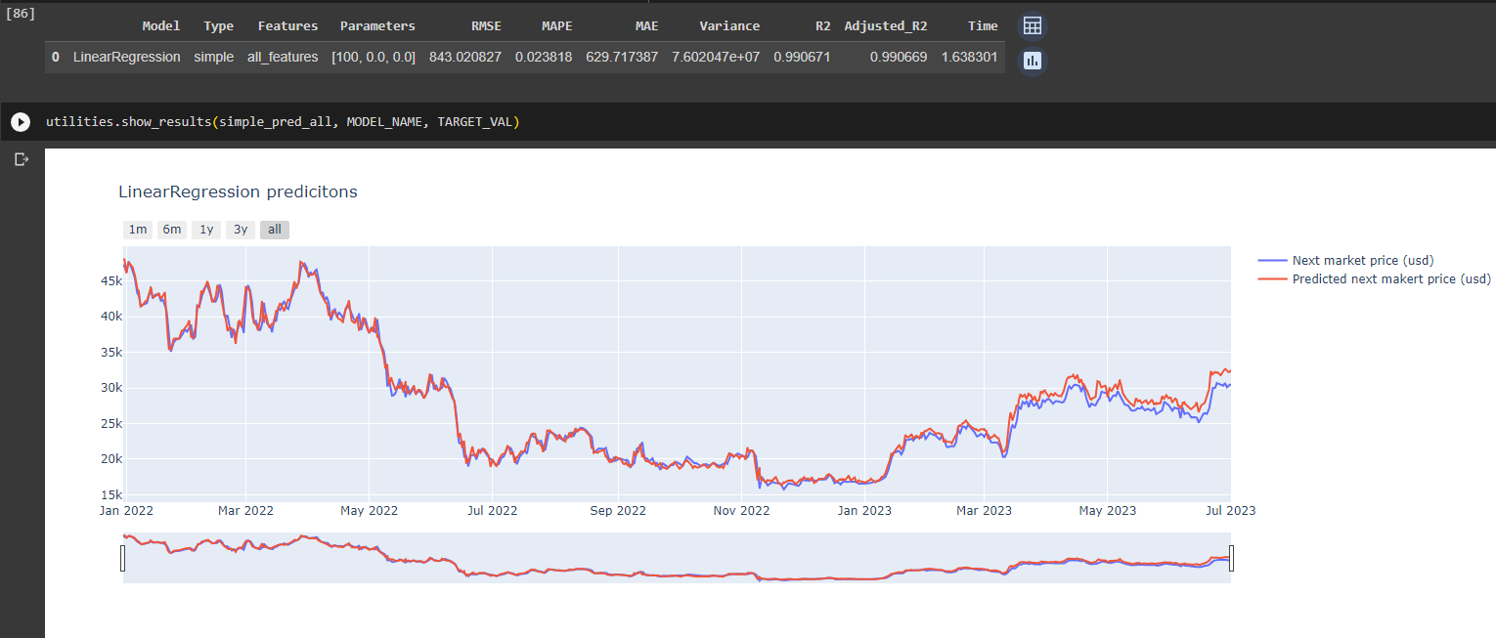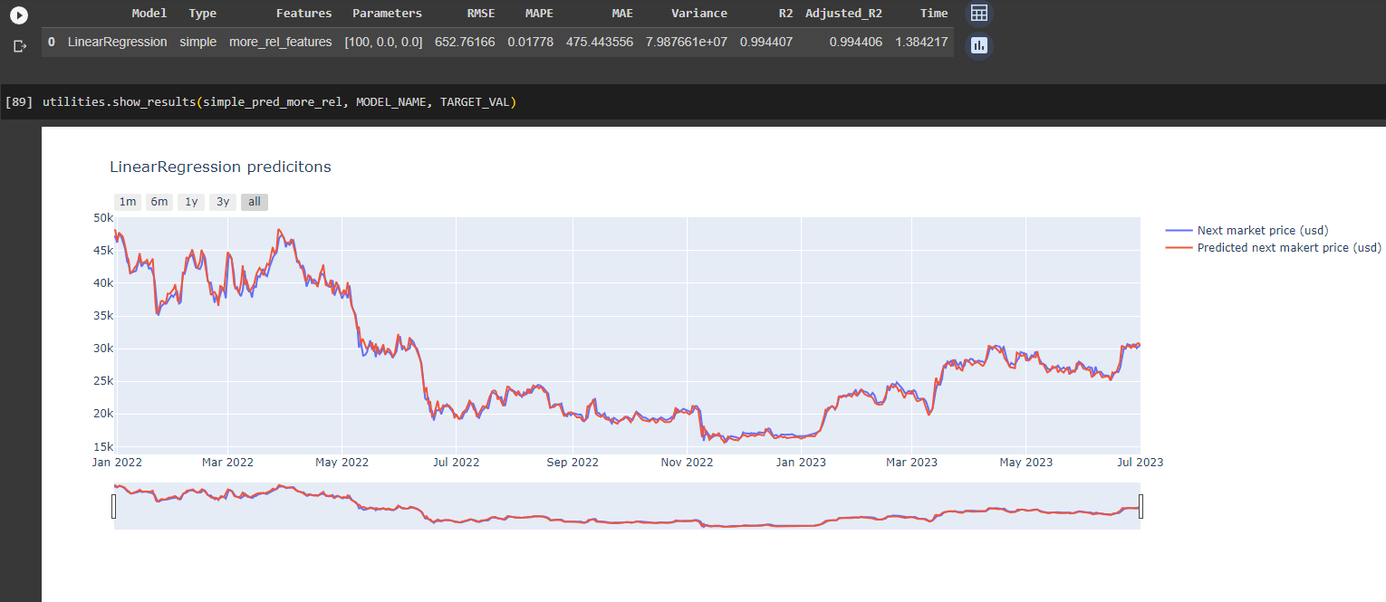

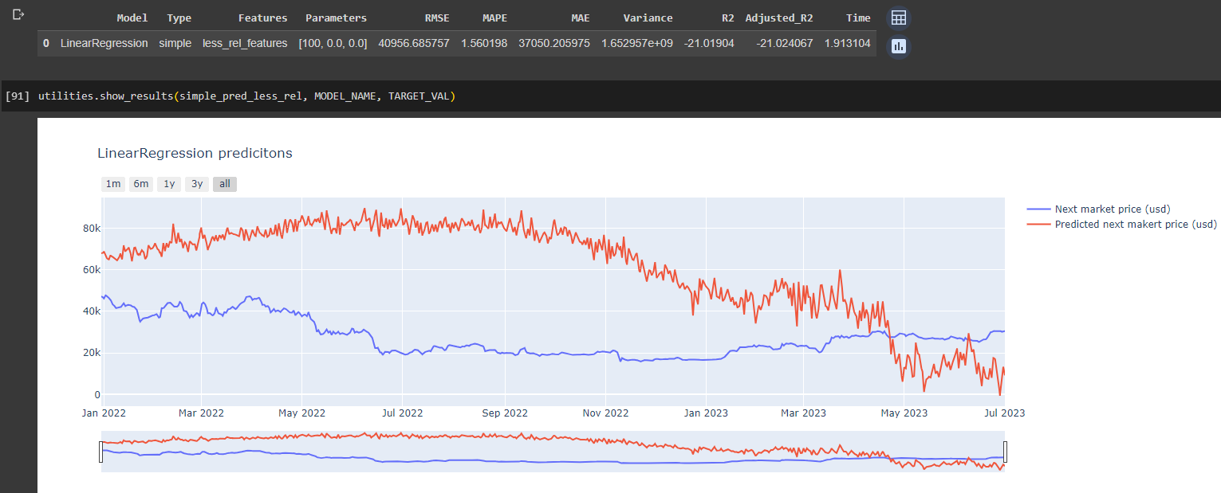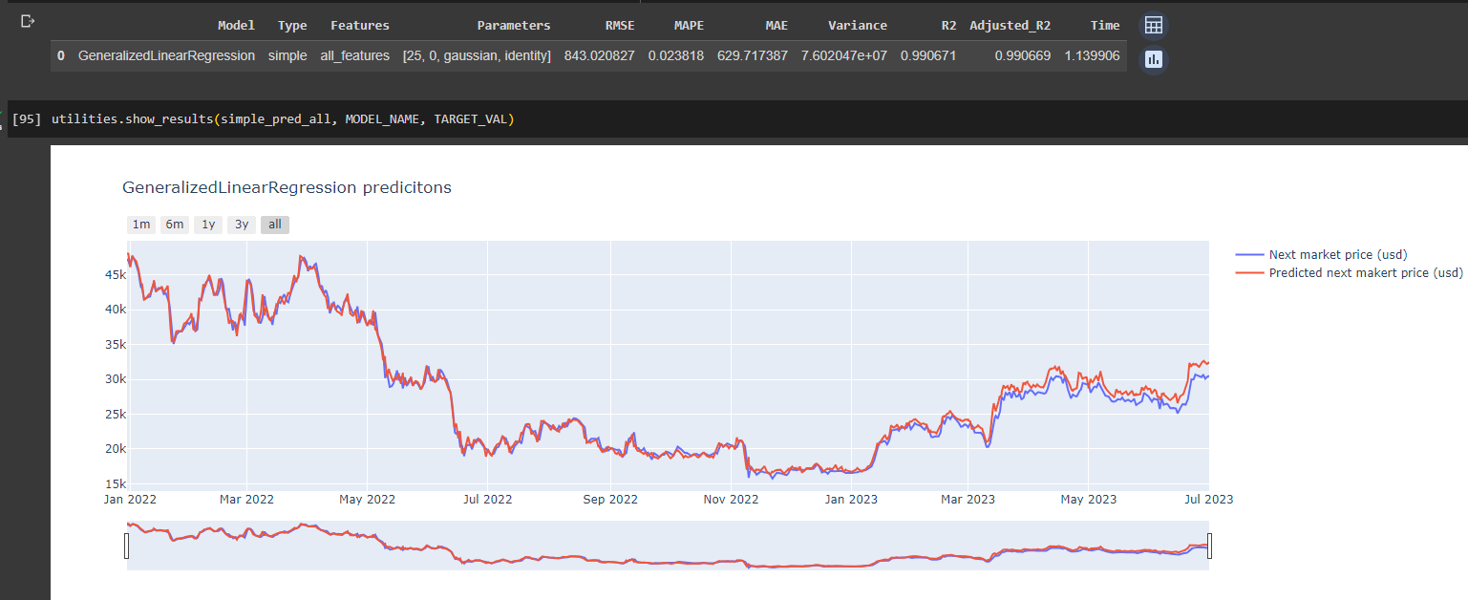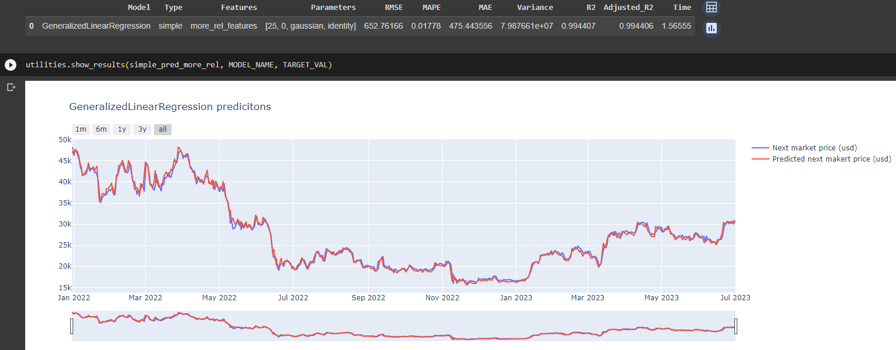

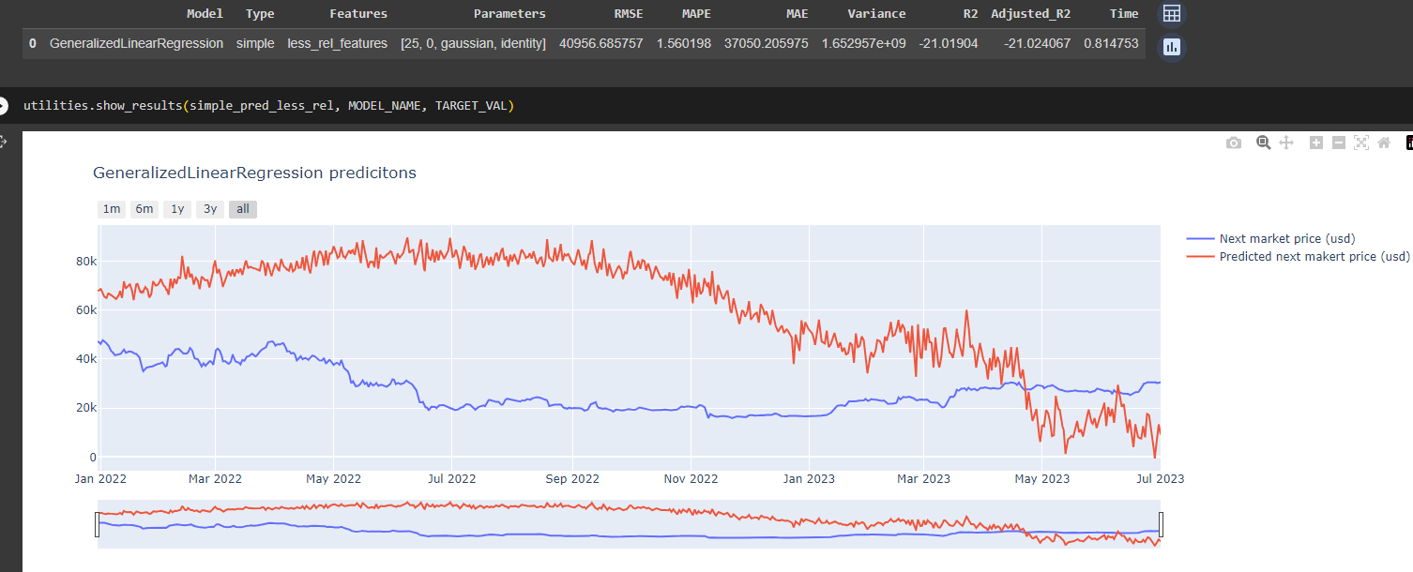

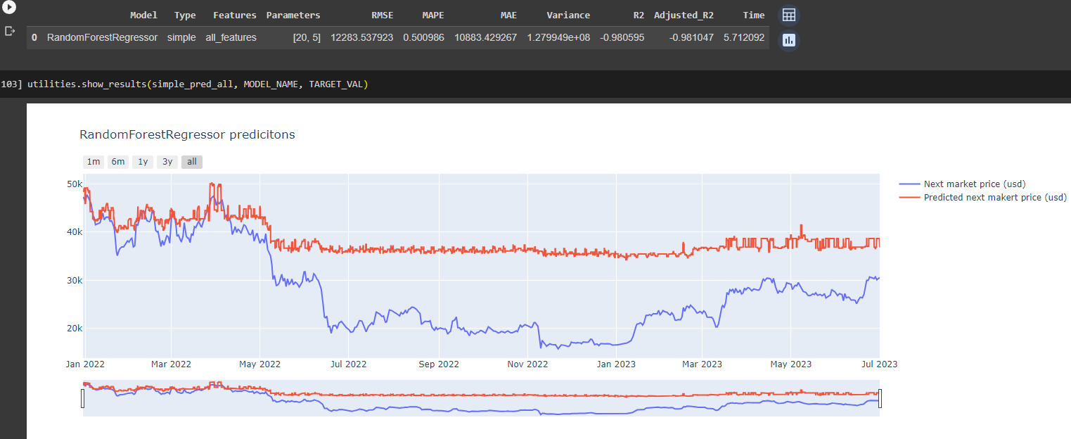

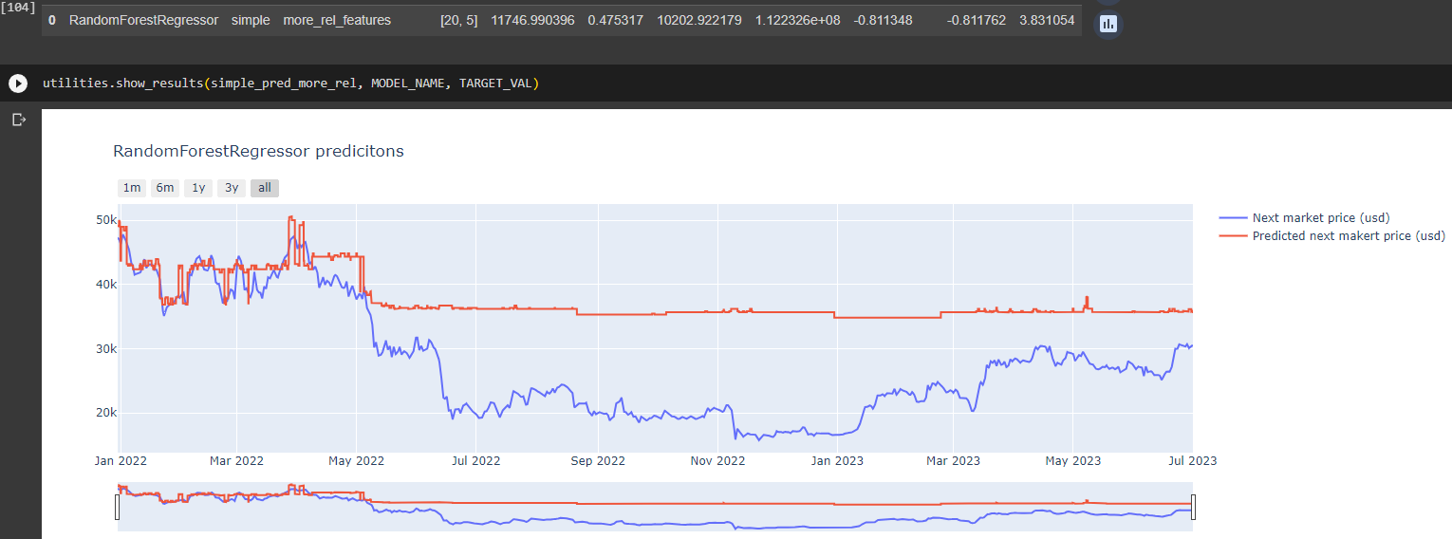

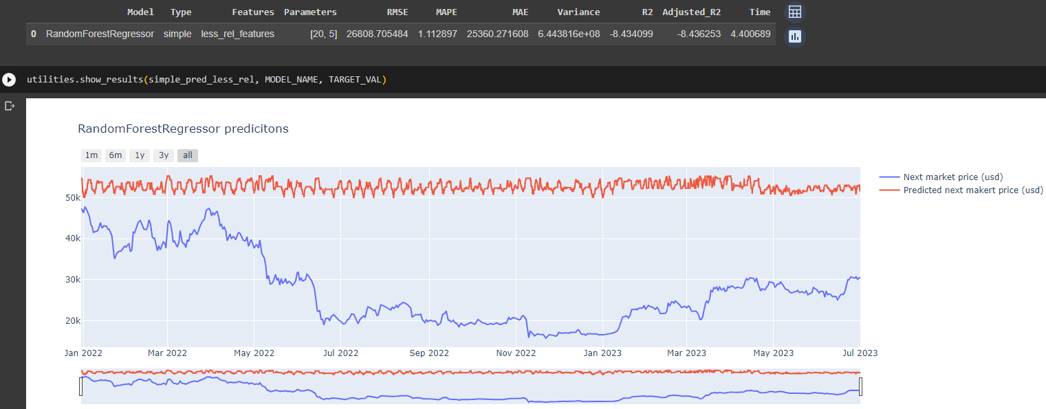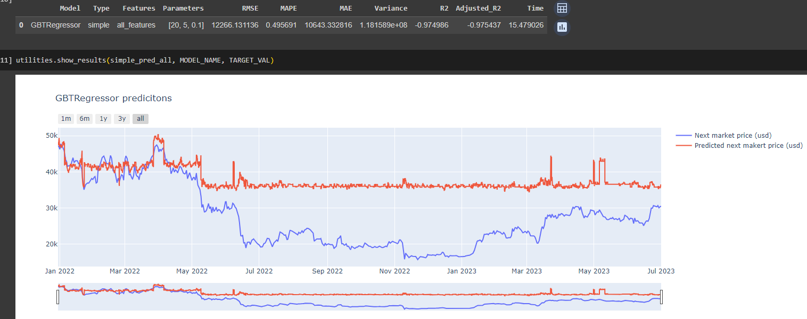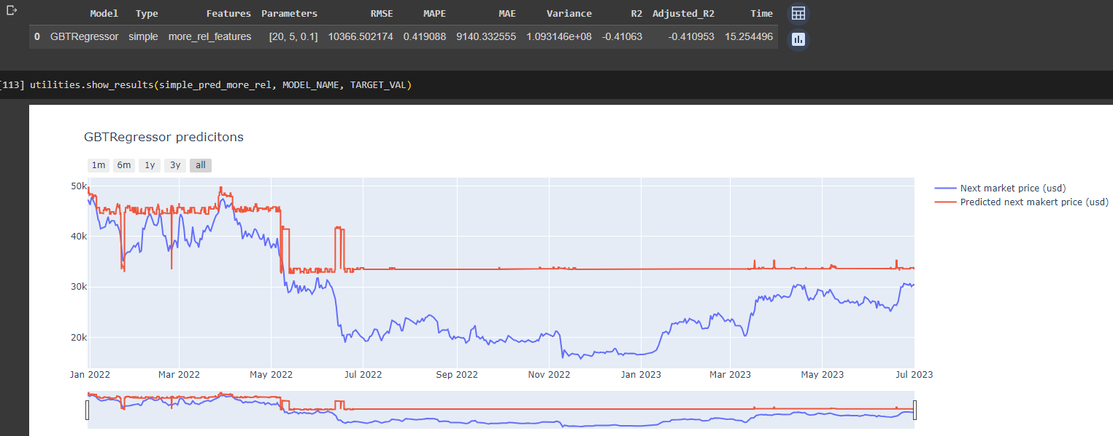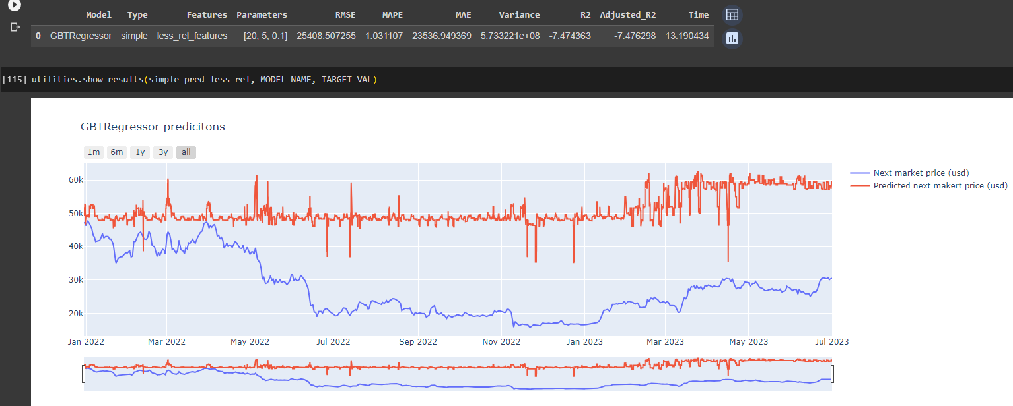

------------------------------------------------------------------------------------------------------------------------------------------

Risultati final

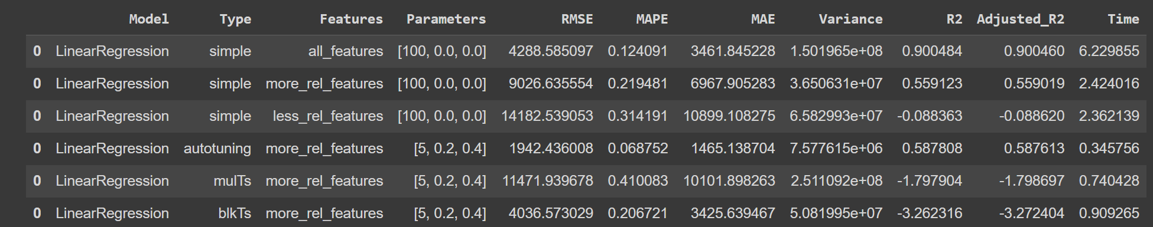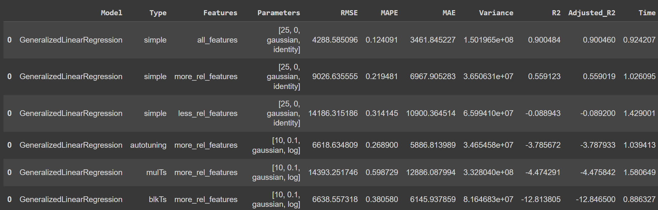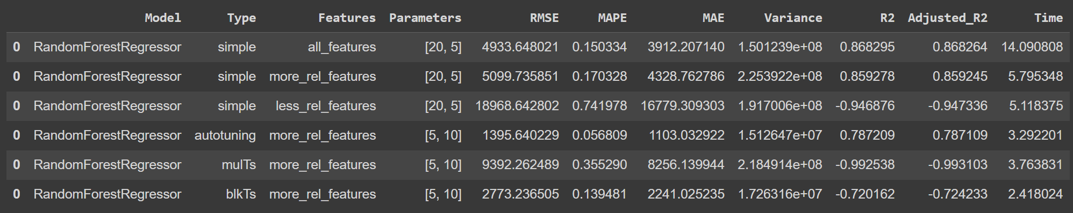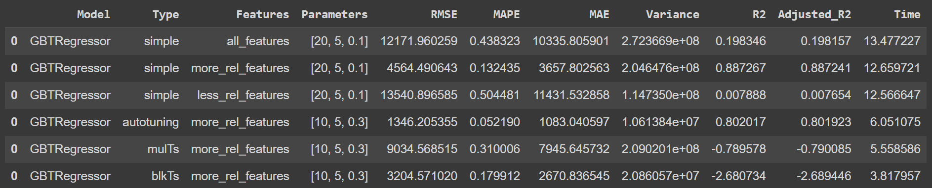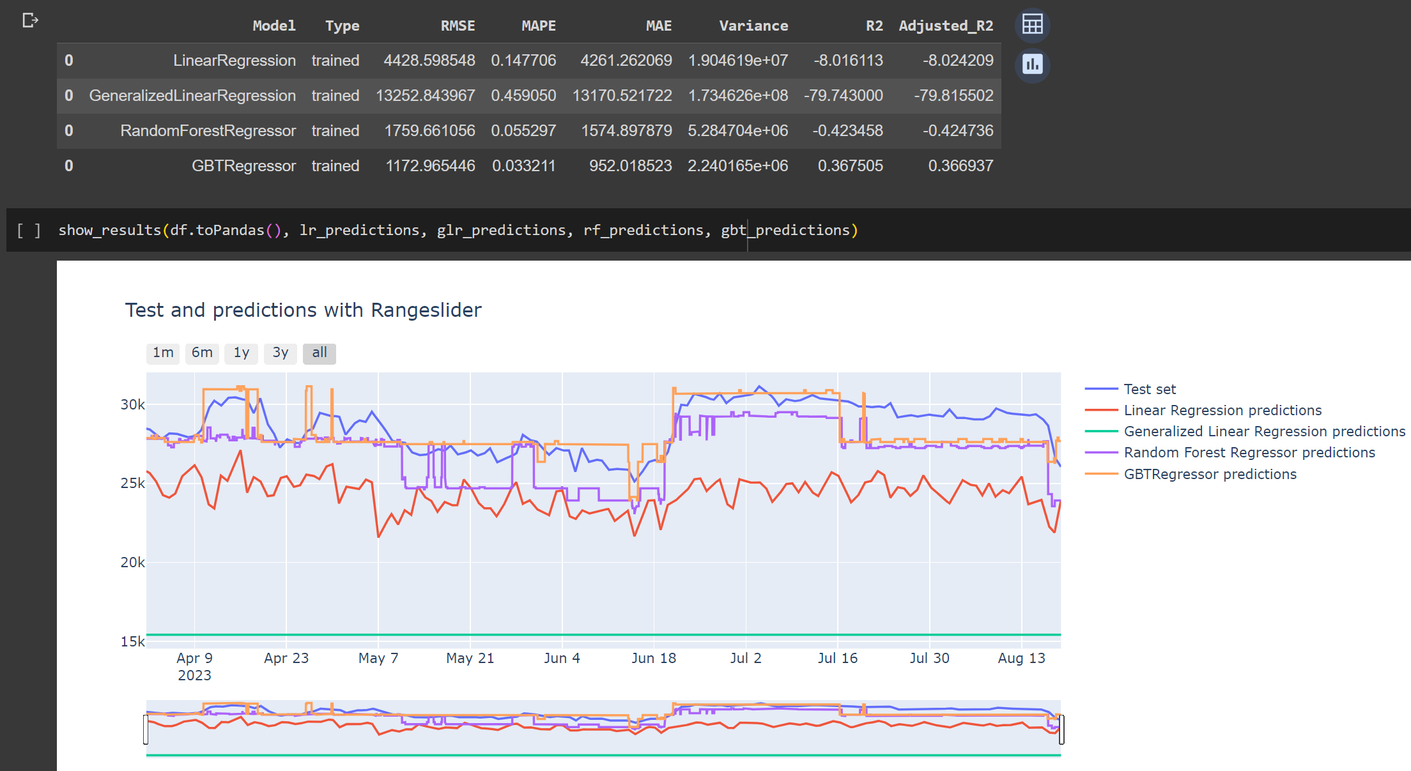

------------------------------------------------------------------------------------------------------------------------------------------

Risultati final (all features)

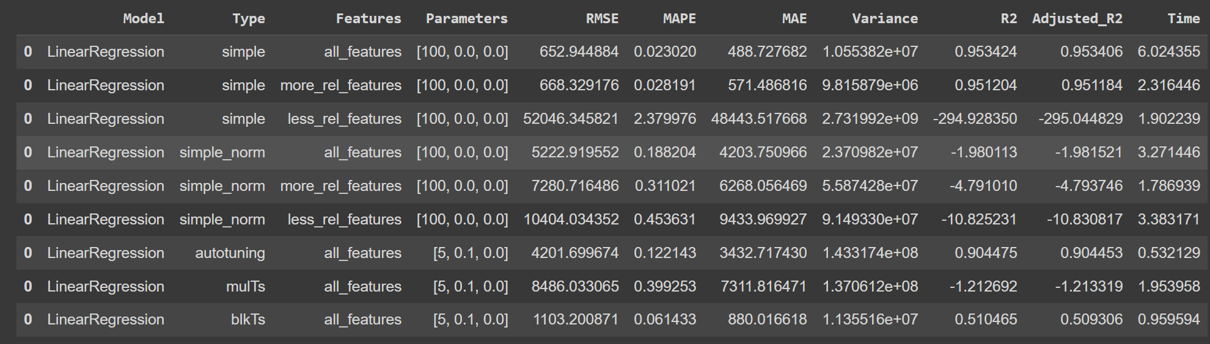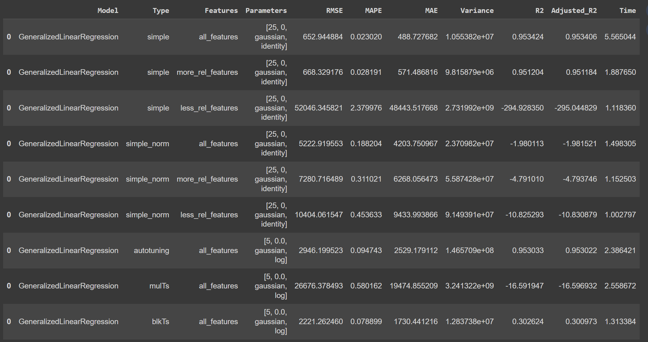

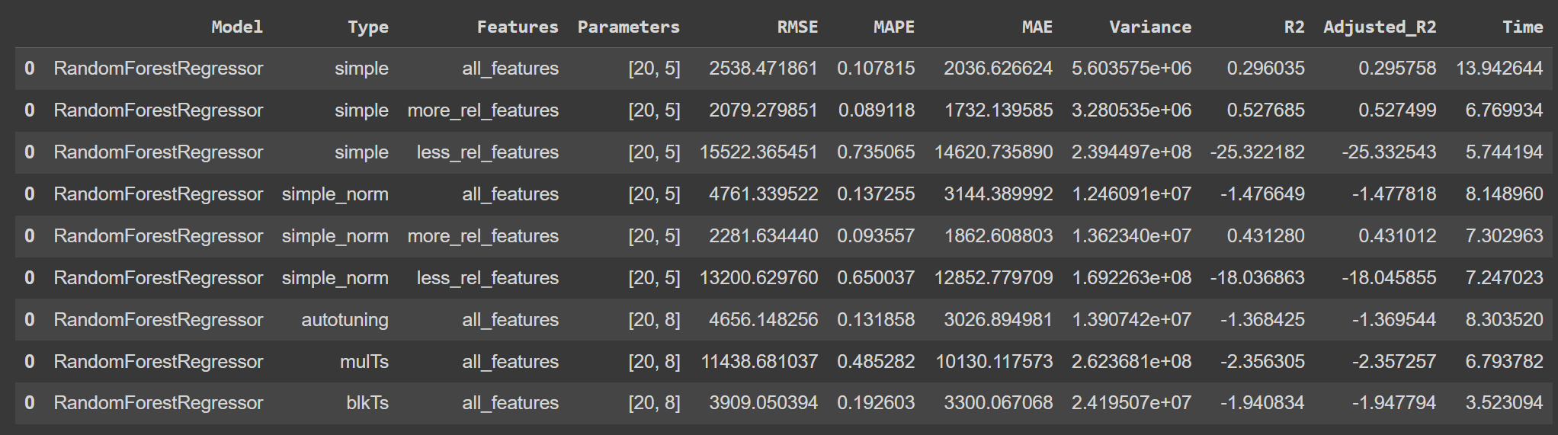

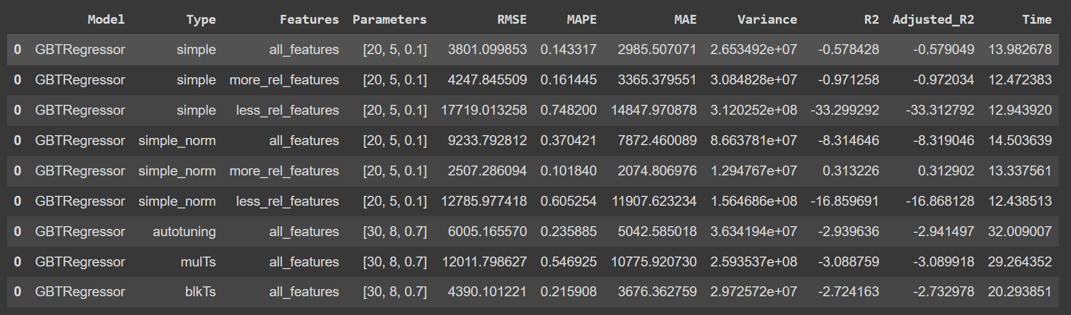

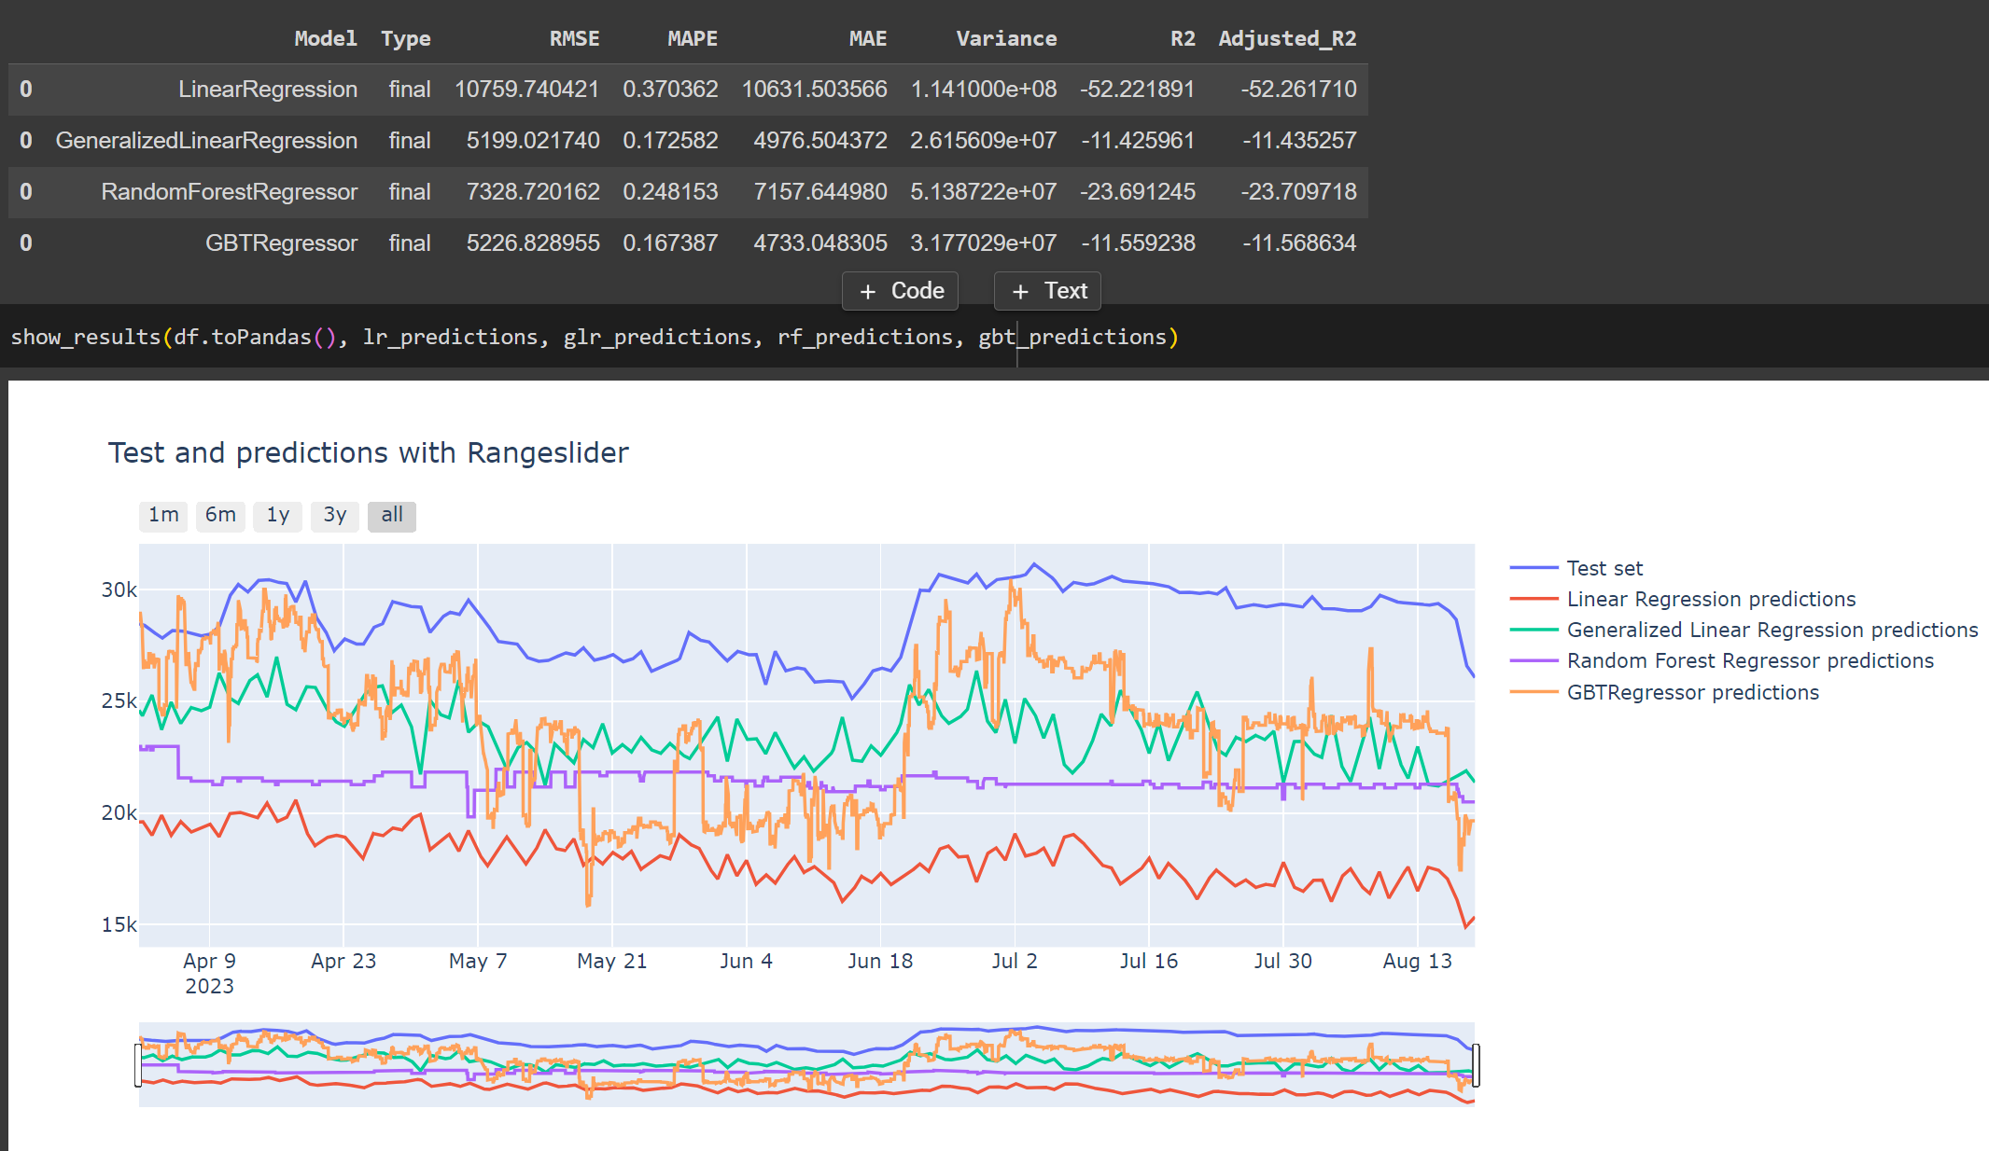

------------------------------------------------------------------------------------------------------------------------------------------

# Risultati (all features normalized with next-market-price) ❌

In generale la normalizzazione aiuta a non far overfittare linear e generalized regression e migliora quelli basati sugli alberi. I linear regression vanno meglio con all_features, quelli basati sugli alberi invece vanno meglio more_relevant, inoltre i risultati finali sono “piú precisi” ad una settimana mentre da 1 mese in su sono peggiori ma non c’è tanta differenza tra 1 – 2 - … mesi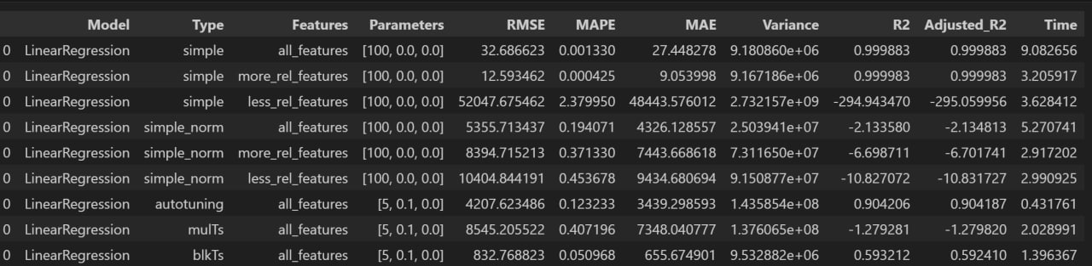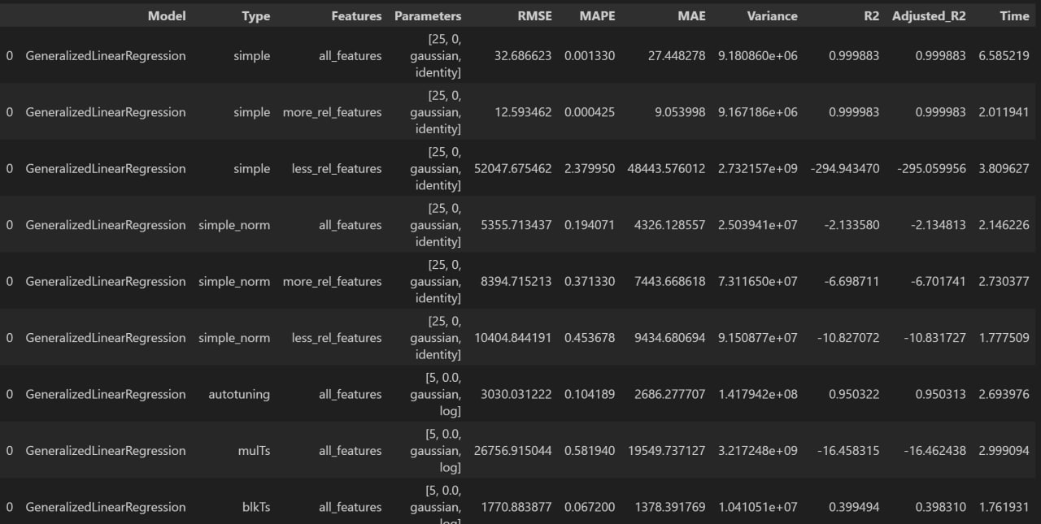

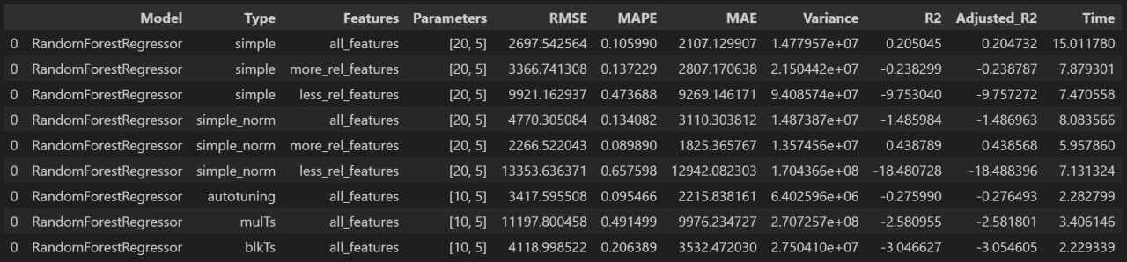

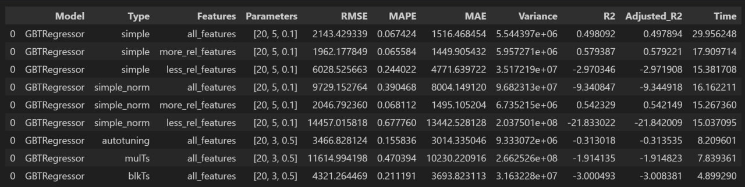

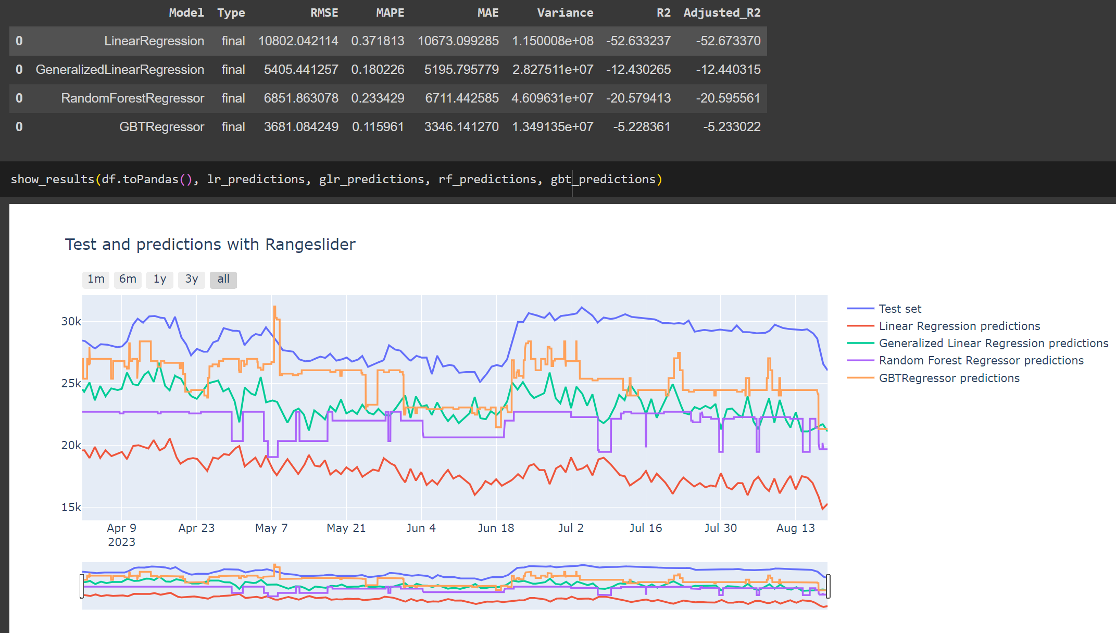

# Risultati (More relevant features normalized with next-market-price) ❌

Sembrerebbe esserci un qualche problema riguardo la parte finale dove validi e traini il modello, in teoria final_validated dovrebbe andare meglio dei simple e final_trained dovrebbe essere top poiché viene allenato sullo stesso dataset dove effettua le predizioni (questo accade solo per i modelli ad alberi mentre per quelli lineari sfaciola tutto)

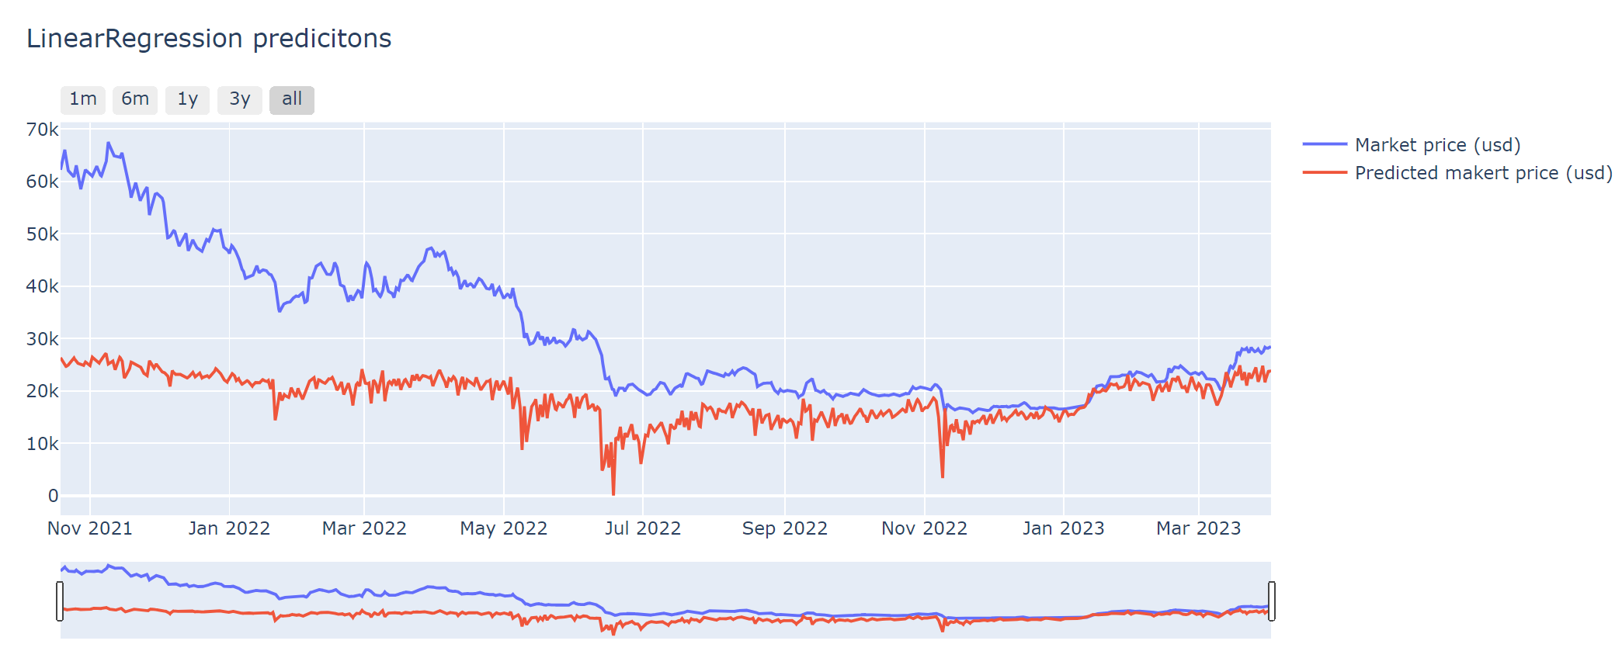

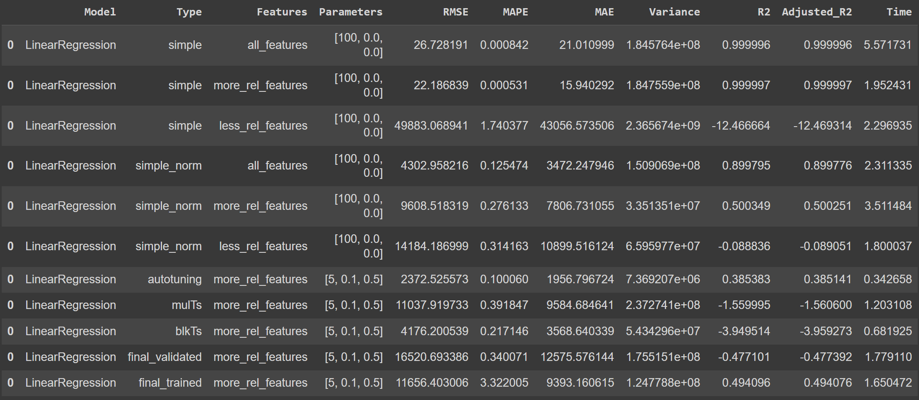

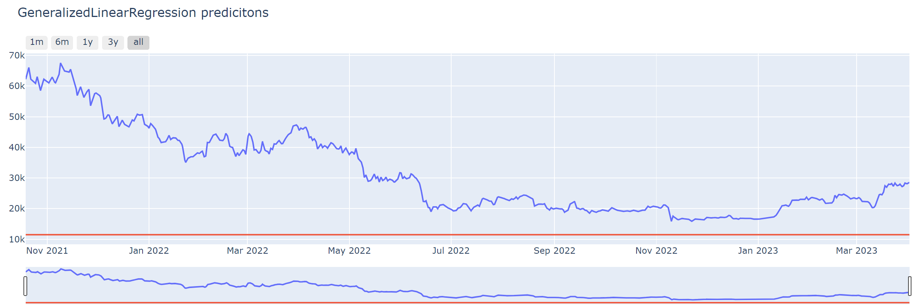

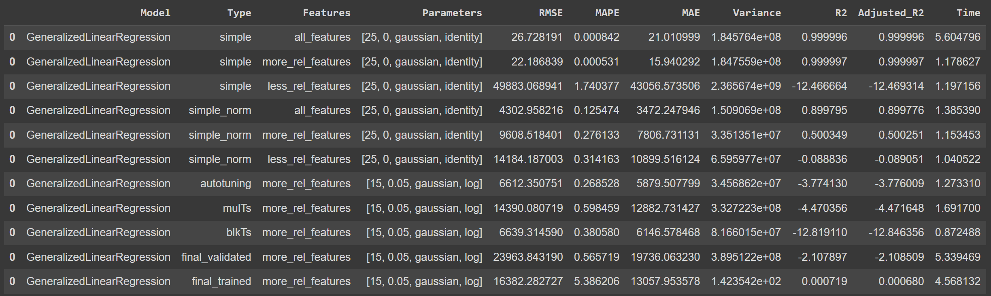

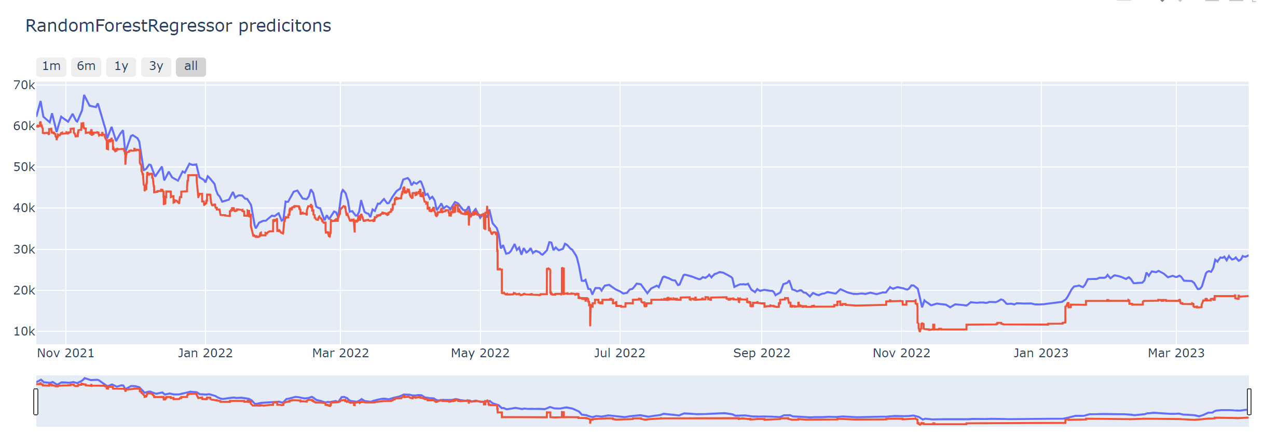

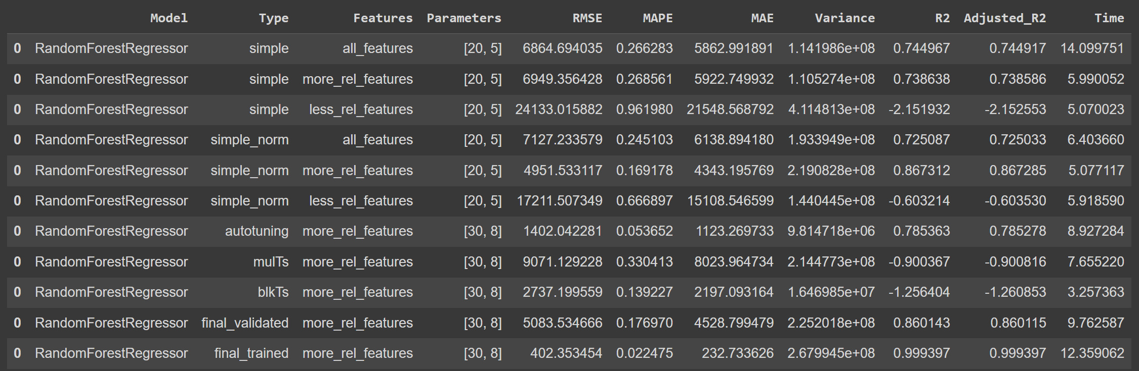

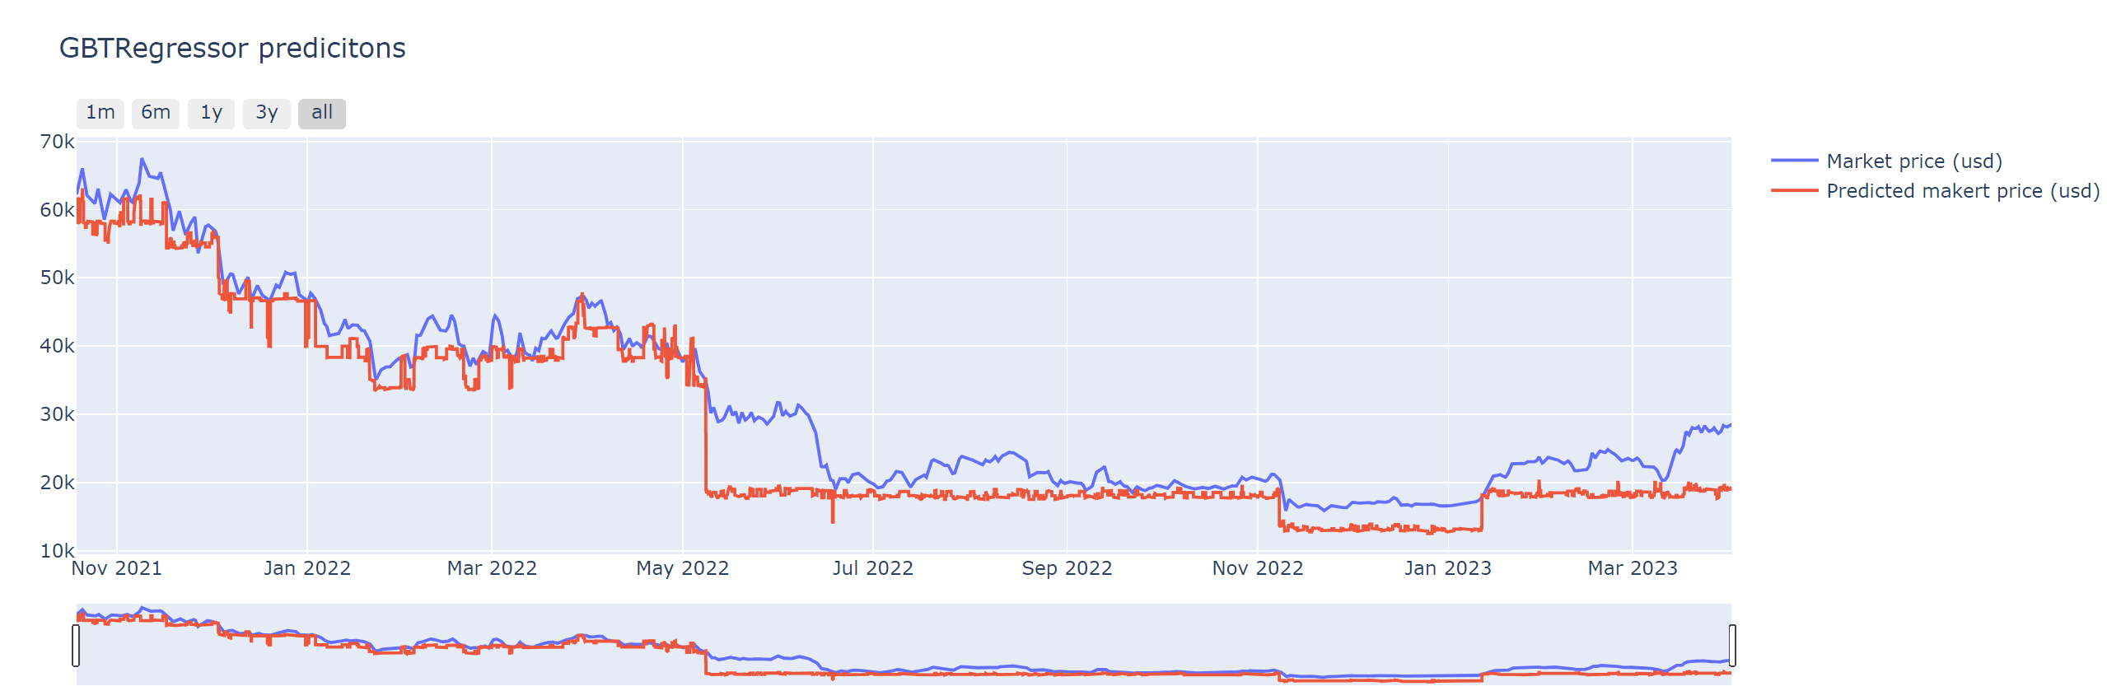

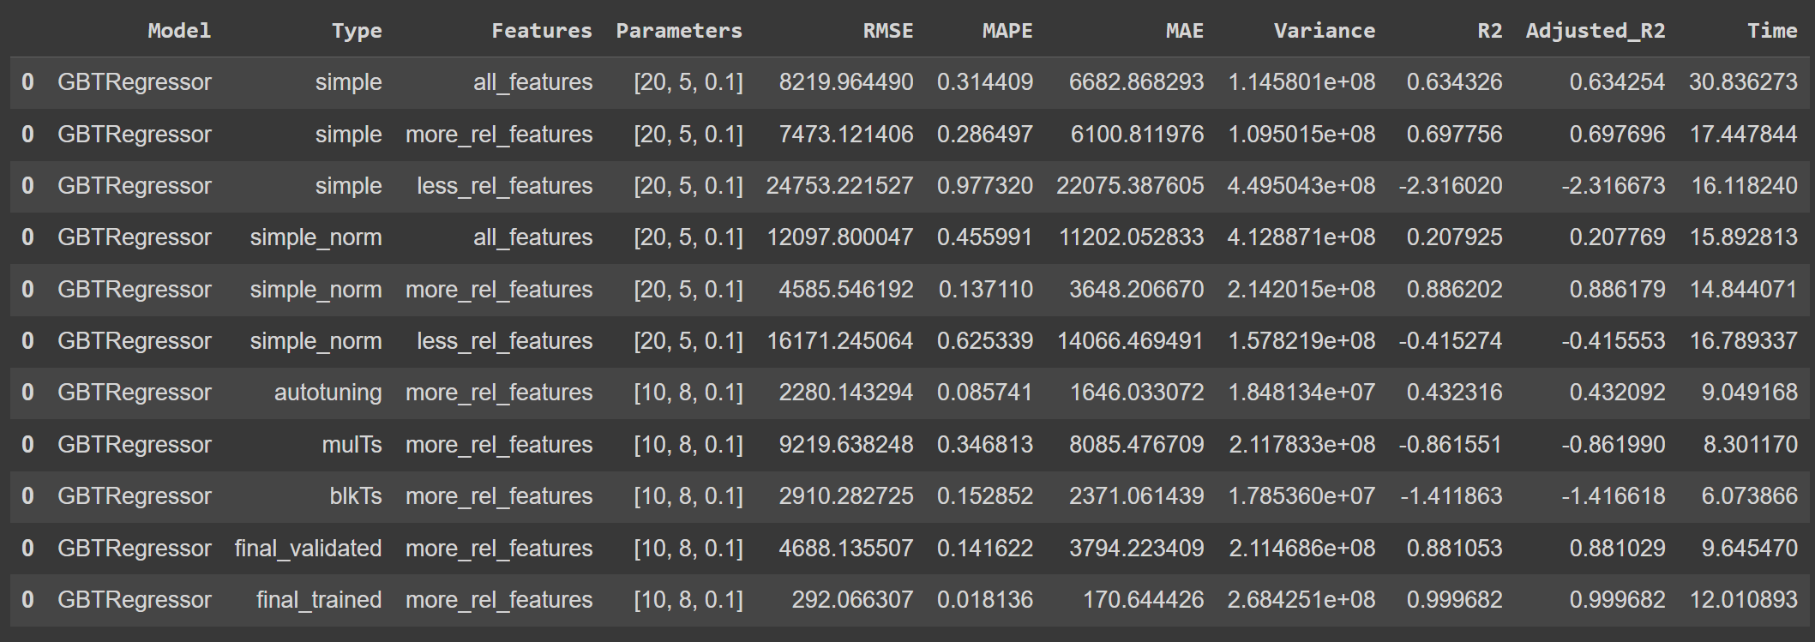

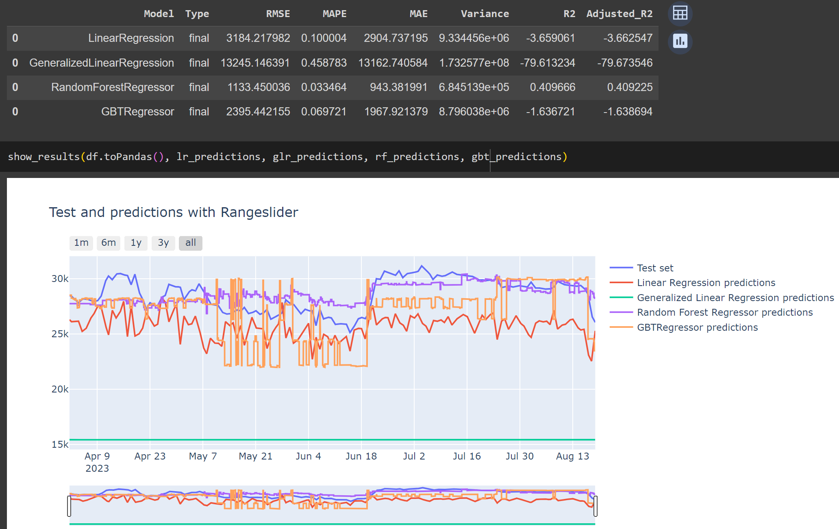

# Risultati (More relevant features normalized with next-market-price ma con hyp. Tuning e cross validation di Alessio) ❌

Come prima, I linear regression vanno male in entrambi i casi (train e testing) mentre gli alberi vanno benone (anche se fanno un pochino piú schifo rispetto a prima)

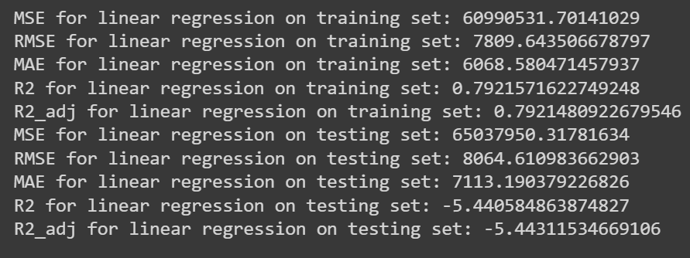

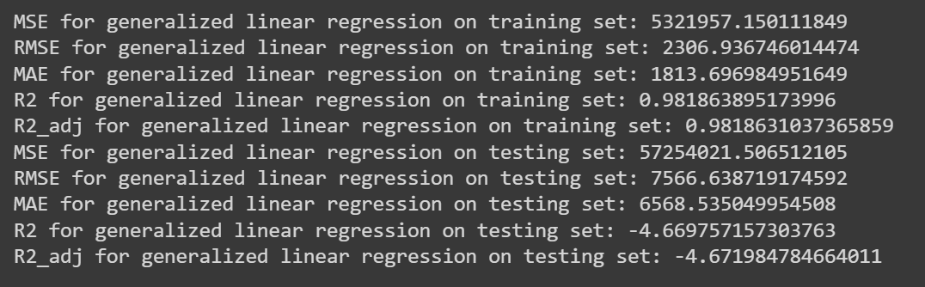

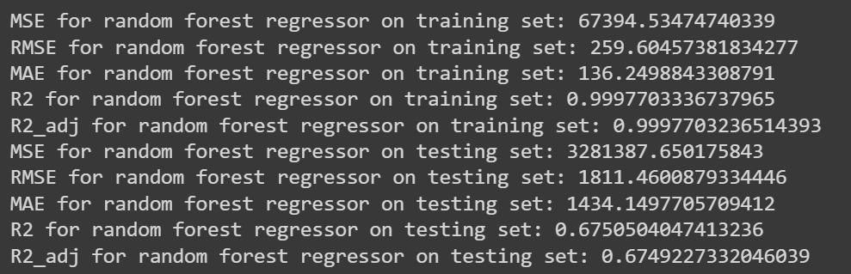

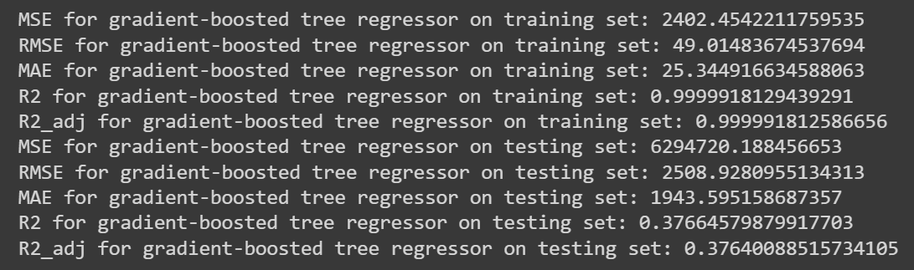

# Risultati (More relevant features normalized with next-market-price con mia hyp. Tuning e cross validation) ✅

